Science 8 Name:___________________ Hr: ___
Unit 1 Review: Water Systems on Earth
Chapter 1: The water cycle plays a vital role on earth
- Draw a diagram of the water cycle. Your diagram should include the following;
  - The source of energy for the water cycle
  - The 4 water sources
  - 2 changes of state
  - Run-off
  - Precipitation
  - The lithosphere
  - Atmosphere and hydrosphere
- Complete the table comparing fresh and salt water.
 | Fresh Water | Salt Water
Percent of water on earth
Freezing point
Density
Salinity

- Use the diagram to answer these questions
  - This diagram shows an example of one of the terms from this chapter. What is this term?

  - Add labels on the diagram to indicate a stream, a river and an ocean.
  - Based on the drawing what do you think happens between drainage basins?
  - Give two reasons why pollution from a factory can affect the ocean.
  - How can a farm be a source of pollution to a river?
- Why will too much turbidity cause a lack of oxygen in the water of a river?
- What is the effect of temperature on dissolved oxygen?
- What is the pH of a neutral substance? What is the pH of an acidic substance? What is the pH of a basic substance?
- Describe how periods of climate change affects glaciers. How does this affect the environment?
- Describe how ocean basins and continental drainage systems are created. Include volcanic action, plate tectonics, erosion and glaciation in your answer.

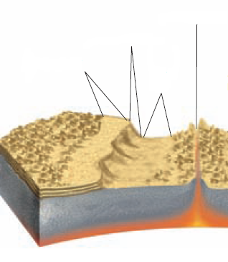
- Label the diagram.

Chapter 2: Oceans control the water cycle
- Name two currents that are important in Newfoundland and Labrador and compare their temperature.
- Name two types of ocean currents and discuss their differences regarding depth.

- Name 3 factors that affect surface currents.

- Name two factors that affect deep currents.
- When warm water and cold water meet, which one floats, which one sinks and why?
- When really salty water and less salty water meet, which one floats, which one sinks and why?
- Explain why the surface current of the Gulf Stream sinks and becomes a deep current when it reaches the Arctic.
- Give two reasons why water at the bottom of the ocean is colder than water at the surface.
- Explain the difference between the mixing layer, the thermocline, and the deep ocean.
- Draw a diagram showing ocean upwelling. Why is upwelling important to the fishery?
- Draw a diagram that shows the differences between swells and breakers. What is the difference?
- Make a diagram and indicate the following parts of a wave: Trough, crest, wave length, wave height.
- What causes a Tsunami?
- Define tide. Explain how tides are created.
- The effect that waves and tides have on the shoreline is influenced by 4 factors. What are they?
- What is the difference between a headland and a bay?
- Describe how erosion and deposition from wave action affects the following: beaches, shoals, sand bars, sea caves, sea arches, sea stacks.

- Describe three types of technology used to study the ocean.
Chapter 3: Bodies of water influence climate and species distribution.
- Complete the following table on the effects of depth on abiotic factors of the ocean.
Abiotic Factor | How depth affects each factor.
Light
Temperature
Salinity
Pressure
Dissolved Oxygen

- Explain why we have a lot of fog in St. John’s.

- Why spring so late, and summer so much cooler in St. John’s and other coastal areas, than other more central parts of Newfoundland?

- Explain how the wind causes differences in air temperature.

- Complete the table about the differences between El Niño and La Niña?
 | El Niño | La Niña
How trade winds are affected
Ocean Temperature
Weather patterns
Marine productivity

- Describe some positive and negative effects of marine technology on ocean species.
- Discuss how new technologies have contributed to overfishing.

- Discuss how the offshore oil industry impacts marine environments.
- Discuss potential impacts that aquaculture technologies have on marine environments.

