Science 8 Name: ____________________________ Class: ______

Unit Review Sc8.2: Optics

Review Sc8.2.1: Light

Vocabulary
diffuse reflection | wavelength | refraction
dispersion | rectilinear propagation | spectrum
frequency | reflection | specular reflection

- ___________________________: A property of light that says it travels in a straight line.
- ___________________________: When light hits a surface and rebounds in another direction.
- ___________________________: Type of reflection: occurs on a smooth surface, reflects clear images.
- ___________________________ : Type of reflection: occurs on rough surfaces, does not form an image.
- ___________________________: When light changes directions passing from one medium to another.
- ___________________________: When the different colours of white light are separated into the colours of the rainbow.
- ___________________________: the number of oscillations (wavelengths) that occur in a second. Measured in Hertz.
- ___________________________: the distance between two crests or two troughs of a wave.
- Electromagnetic___________________________ : The series of electromagnetic waves in every wavelength and every amount of energy.
Questions

- What was Pythagoras’ theory of light?
- Why didn’t Galileo succeed in measuring the speed of light?
Who was the first to succeed at measuring the speed of light?
- What is the speed of light, in a vacuum?
- What travels faster, light or sound?
When we see a flash of lightning, why is there a few seconds or so before we hear the thunder?
- Name 5 examples of optical technologies.
- Name the 6 properties of light.
- Which property of light is demonstrated by each example?

Situation | Property of light
The light from a faraway star reaches Earth.
Light passes through air.
You see your image in a mirror.
We see a rainbow after it rains.
You see your shadow.
The colour of an apple is red.
When you look at a sheet of paper, the light is not absorbed, but you don’t see your image.

- What is the difference between diffuse reflection and specular reflection, and give an example of each.
- Explain wavelength and frequency. What is the relationship between them?
- If a wave has a high frequency,
  - Is its wavelength longer or shorter?
  - Does it have more or less energy?
- Draw a diagram of the electromagnetic spectrum that represents the types of electromagnetic radiation from radio to gamma waves.
- In the Electromagnetic Spectrum
  - Which type of waves have the longest wavelength?
  - Which type of waves have the shortest wavelength?
  - Which type of wave has the least amount of energy?
  - Which type of wave has the highest amount of energy?
- Name the uses and possible dangers (if applicable) of each type of radiation.

Review Sc8.2.2 : Reflection

Vocabulary
principal axis | focal point | normal | reflection
concave | incidence | plane | reflected
convex | incident | real | virtual

- ___________________________ ray: the ray that hits the mirror.
- ___________________________ ray: the ray that rebounds off of the mirror
- ___________________________: an imaginary line perpendicular to the surface of the mirror.
- ___________________________ angle: the angle between the incident ray and the normal.
- ___________________________ angle: the angle between the reflected ray and the normal.
- ___________________________: a flat surface.
- ___________________________: hollow, like the interior of a sphere.
- ___________________________: bulging, like the exterior of a sphere.
- ___________________________: The point at which the reflected rays converge (come together), parallel to the principal axis of a curved mirror.
- ___________________________: An imaginary line, perpendicular to the mirror, that passes through the focal point of the mirror.
- ___________________________ image: an image formed when the reflected rays intersect in front of the mirror.
- ___________________________ image: an image formed when the reflected rays do not intersect in front of the mirror, but on the opposite side of the mirror by extending the reflected rays.

Questions

- What is the law of reflection?
- Name three types of mirrors and explain two uses for each.
- Explain the significance of each letter in “S.P.O.T.”
- Explain the difference between a virtual image and a real image.
- Make a ray diagram to find the image of the sun in a plane mirror. Give the characteristics of S.P.O.T. for the image.
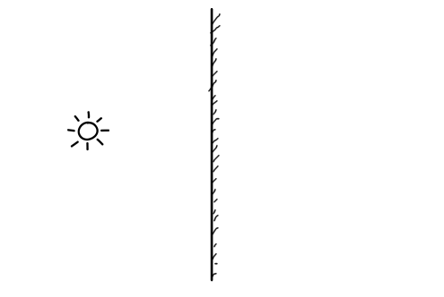
- Describe the two important rays that must be used when drawing a ray diagram for a curved mirror.
- Draw the ray diagrams for the objects in the curved mirrors, below. Describe each image using S.P.O.T.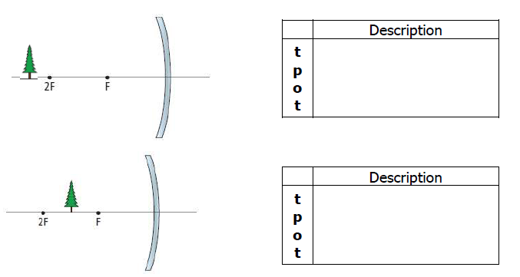
S
S

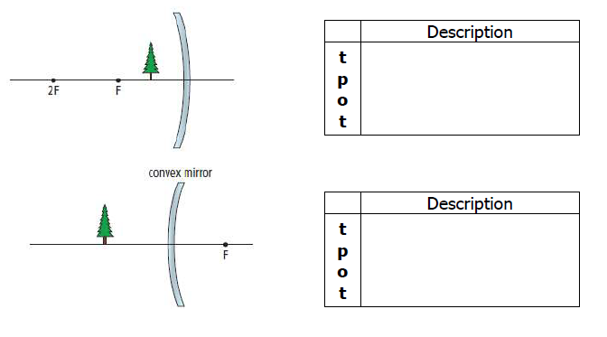
S
S

- What type of mirror produces an image with the following characteristics?
Characteristics | Type of mirror  (plane, concave, or convex)
An upright image, smaller than the object.
An upright image, always the same size as the object.
An image that is upside down, but smaller than the object.
A mirror that can concentrate the rays of light from the sun, on a solar oven.
An upright image, always the same distance from the mirror as the object, but behind the mirror.
A mirror used to see a large field of view behind you.
A mirror to see your face up close, for makeup or shaving.
An upright image, bigger than the object.
A mirror used to direct light in a flashlight.

Review Sc8.2.3: Refraction

Vocabulary
convergent | divergent | lens | near-sighted | far-sighted
refracted | refraction

- ___________________________ ray: the ray after refraction occurs.
- Angle of ___________________________: the angle between the refracted ray and the normal.
- ___________________________: A curved piece of glass that refracts light to form images.
- ___________________________ : to come together.
- ___________________________ : to separate.
- ___________________________: When you are able to see objects up close, but not far away.
- ___________________________: When you are able to see objects that are far away clearly, but not as they become closer.

Questions

- Give two examples of refraction.

- Create a diagram to represent a ray of light that is refracting as it passes between air and water. On your diagram, include:
  - Air, water, incident ray, refracted ray, normal, angle of incidence, angle of refraction

- When a ray of light passes from air and to a denser substance, in what direction does the light refract?
- When a ray of light passes from a more dense substance to air, in what direction does the light refract?
- What effect does the density of a substance have on the speed of light?
What effect does it have on a ray of light that enters it?
- What colour of light is refracted the most as it passes through a prism, red or violet?
- What wavelength is refracted the most as it passes through a prism, a longer wave or a shorter wave?
- Draw a picture of each of the following:
  - A convex mirror
  - A concave mirror
  - A convex lens
  - A concave lens

- Draw a diagram to represent refraction in a convex lens. Label the principal axis, the incident rays, the refracted rays, and the focal point.
- Draw a diagram to represent the refraction of a concave lens. Label the principal axis, the incident rays, the refracted rays, and the focal point.
- What type of mirror is convergent?
What type of mirror is divergent?
Draw a small diagram of each mirror.
- What type of lens is convergent?
What type of mirror is divergent?
Draw a small diagram of each lens.

- What type of lens is necessary for a person who is near sighted? Explain how this lens will help.
- What type of lens is necessary for a person who is far sighted? Explain how this lens will help.
- Name three types of optical instruments that use lenses.

