Unit 4 Study Guide Sc8.4: Cells, tissues, organs and systems

Chapter 10 Booklet Sc8.4.1: The microscope and cells

Definitions

cell | cell membrane | nucleus | cell wall
chloroplast | mitochondria | organelles | vacuole
cytoplasm | mitosis

1. _________________________________: the basic unit of life.
2. _________________________________: parts that make up the cell.
3. _________________________________: thin film that surrounds all cells.
4. _________________________________: transparent gel that fills the cell and contains other organelles.
5. _________________________________: organelle which is hard and rigid, composed of cellulose, which surrounds plant cells.
6. _________________________________: big round organelle that contains the chromosomes in the cell.
7. _________________________________: a "bubble" in the cell; can contain water, waste, or a reserve of food. Bigger and more important in plant cells.
8. _________________________________: small organelle in the form of bean that uses oxygen to 'burn' food and release energy for the cell (cellular respiration)
9. _________________________________: Green organelle that contains chlorophyll and makes photosynthesis; exists only in plant cells.
10. _________________________________: process where cells divide into two to make new cells.

- Label the parts of a microscope.

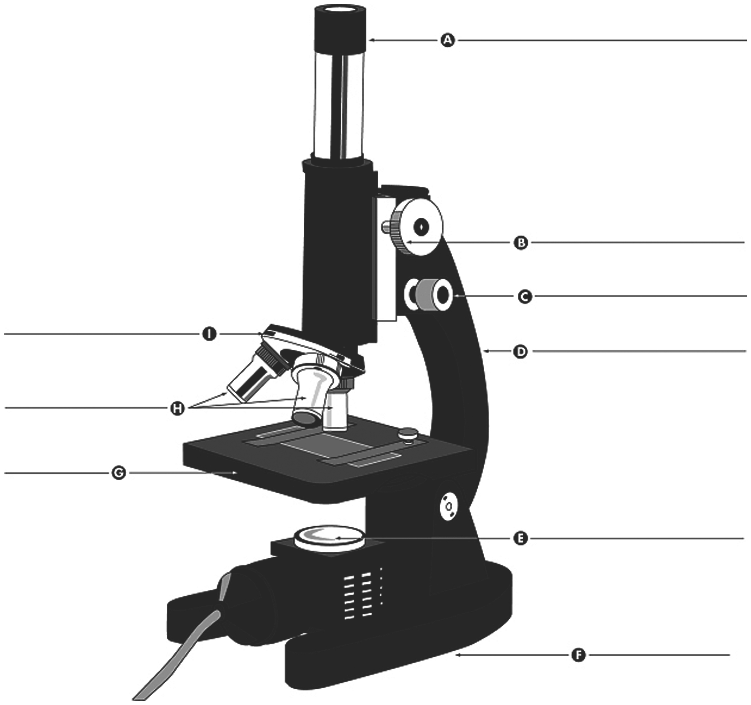

- Draw and label "typical" animal and plant cells and label all parts that were studied (5 parts for animal cells and 7 for plant cells)

- Look at the cells below. For each cell
(a) Say if it is a plant or animal cell
(b). Label all organelles you know on the diagram.
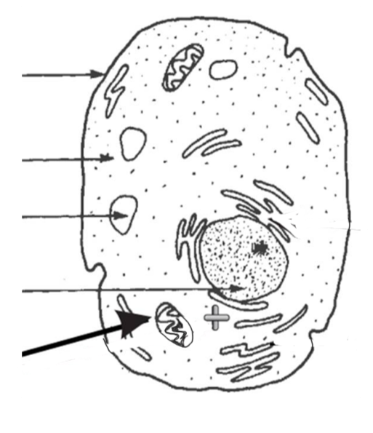
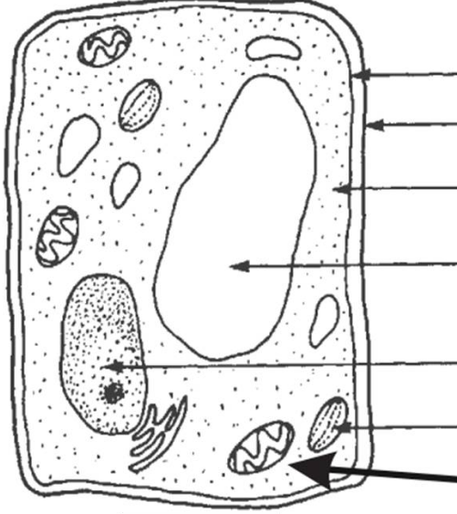

- What are the four differences between plant and animal cells?
- Why do animal cells not have chloroplasts?

- Why do plant cells need cell walls?

- What is the function of the nucleus?

- What is the name of the gel that fills the inside of the cell?

- What is the name of the large organelle that stores water in the plant cell called?

- What organelle allows materials to enter and exit the cell?

- If a cell didn't have mitochondria, what would be the problem for this cell?

Chapter 11 Booklet Sc8.4.2: Tissues, organs and organ systems

Definitions

Circulatory | Nervous | Respiratory
Waste | Nutrient | Organ System
Digestive | Organ | Tissue
Muscular | Cellular Respiration | Excretory

- ____________________: a group of similar cells.
- ____________________: a part of the body made of two or more types of tissue, which has a specific function.
- ____________________: a group of organs that work together to perform a necessary function for the body.
- ____________________: when the cells in the mitochondria use food and oxygen to release energy, and produce carbon dioxide and water as waste products
- ____________________: substance needed from food.
- ____________________: substance that must be eliminated from the body.
- The ____________________ System: the system responsible for transporting oxygen, food and waste to the different parts of the body.
- The ____________________ System: the system responsible for bringing in oxygen and eliminating carbon dioxide.
- The ____________________ System: the system responsible for absorbing nutrients from food, and eliminating solid waste.
- The ____________________ System: the system responsible for eliminating liquid waste from the body.
- The ____________________ System: the system responsible for controlling the activities of the body, and to detect and react to changes inside the body and in the environment.
- The ____________________ System: the system responsible for moving the body.

- Explain the connections between the following terms: cell, tissue, organ, organ system.

- Complete the table :

Organ system | Function of the system | Organs

- Write a short paragraph to explain cellular respiration. Your paragraph should include:
(a) The function of cellular respiration
(b). The name of the organelle responsible for cellular respiration
(c) Substances used and substances produced in cellular respiration.

- How can the cells of your intestine receive oxygen?

- How can the cells in the center of a muscle receive food?

- How can the waste produced by your brain cells can be transported outside the body?

- Complete the table below using the following terms – some terms will be used more than once!
Circulatory | Respiratory | Digestive
Nervous | Muscular | Excretory

Activity or function | Organ system
Takes the carbon dioxide produced by the cells and transports it to the lungs to be eliminated
Eliminates solid waste
Makes different parts of the body move.
Receives information from the 5 senses.
Pump the blood
Digests food
Communicates the instructions from the brain to the body
Exchanges gases - oxygen and carbon dioxide
Removes liquid waste

